
Final system for Mainband
1 | P a g e
1)Format 3
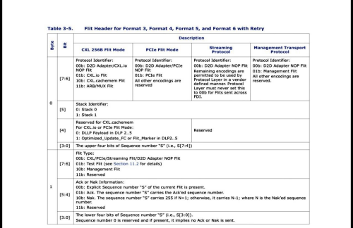2 | P a g e
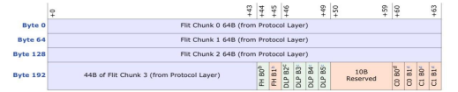
Flit Chunk 0 / 1 / 2 (64B each)
These fields contain the main payload data coming directly from the Protocol Layer. The Adapter does not modify this data and only forwards it as part of the 256B flit.
Flit Chunk 3 (44B)
This is the remaining portion of the protocol payload required to complete the 256B flit size. It is treated as normal data and included in CRC computation.
Flit Header (FH B0, FH B1)
The flit header is inserted by the Adapter. It carries control information such as protocol type, sequence number, and Ack/Nak information when retry is enabled.
DLP Bytes (B2–B5)
These bytes are used by the Adapter to carry DLLP, Optimized Update Marker information. They support flow control and retry mechanisms for PCIe and CXL protocols.
10B Reserved
These bytes are reserved and must always be driven as zero. They do not carry data and are kept for format consistency and future extensions.
CRC Bytes (CRC0 and CRC1)
CRC fields are generated by the Adapter to ensure data integrity. The receiver checks the CRC values to detect transmission errors.
3 | P a g e
2) MainBand
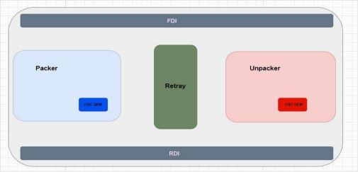
Mainband Block Overview

The Mainband is a core block within the adapter responsible for handling flit level data processing in both the transmit (TX) and receive (RX) paths. It plays a critical role in ensuring that data is correctly formatted, protected, transmitted, and validated according to the required protocol rules. The Mainband acts as the connection point between the protocol layer and the physical interface by managing flit construction, error detection, and control signaling. By coordinating data flow and integrity checks, it ensures reliable communication across the link. The Mainband is composed of several sub blocks, each responsible for a specific function in the data path. These sub blocks are the Packer, Retry , CRC Generator, Unpacker, and CRC Check blocks.
4 | P a g e
3) Packer
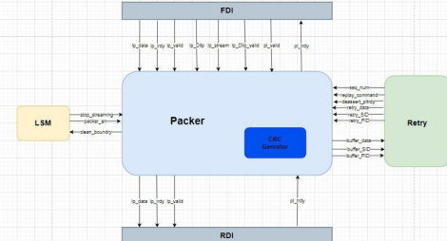
Overview:
The Packer operates in the transmit path and is responsible for constructing outgoing flits. It receives payload data from the protocol layer through the FDI interface and prepares it for transmission.
This block assembles the flit header using control information such as the Protocol ID, Stack ID, sequence number, replay command, and flit type. It then combines the header with the payload data and any required control fields, creating a complete flit structure before CRC insertion.
The Packer ensures that transmitted flits follow the correct format and alignment, making it essential for maintaining protocol compliance and enabling reliable transmission.
5 | P a g e
Signal description :-
Port | Direction | Width | Connected | Description
Lp_irdy_fdi | IN | 1 | FDI | Indicates that the protocol layer is ready to send data.
Lp_valid_fdi | IN | 1 | FDI | Indicates that data from FDI is valid.
Lp_data_fdi | IN | 2048 | FDI | Payload data received from the Protocol Layer via FDI.
Lp_dllp | IN | 32 | FDI | DLLP or optimized flow control information from FDI
Lp_dllp_valid | IN | 1 | FDI | Indicates that the DLLP data is valid.
Lp_dllp_ofc | IN | 1 | FDI | Indicates that the DLLP carries optimized flow control info.
Lp_stream | IN | 8 | FDI | Contains Protocol ID and Stack ID information.
Pl_trdy | IN | 1 | RDI | Indicates that the Adapter is ready to accept a flit.
Packer_en | IN | 1 | LSM | Enables the packer operation in the TX path.
Stop_stream | IN | 1 | LSM | Stops data transmission from the protocol layer.
Seq_num | IN | 8 | Retry | Sequence number assigned to the current flit.
Replay_command | IN | 2 | Retry | Indicates replay or retry control command.
Deassert_trdy | IN | 1 | Retry | Requests deassertion of ready during retry handling.
Retry_data | IN | 1896 | Retry | Payload data retrieved from retry buffer during replay.
Retry_SID | IN | 1 | Retry | Stack ID retrieved from retry buffer.
Retry_PID | IN | 2 | Retry | Protocol ID retrieved from retry buffer.
Pl_trdy_fdi | OUT | 1 | FDI | Indicates that the PHY is ready to receive data from Adapter.
Clean_boundry | OUT | 1 | LSM | Indicates a clean flit boundary after transmission.
Lp_data_rdi | OUT | 2048 | RDI | Complete flit data sent to the RDI interface.
Lp_valid_rdi | OUT | 1 | RDI | Indicates that the flit data sent to RDI is valid.
Lp_irdy_rdi | OUT | 1 | RDI | Indicates that the packer is ready to transmit to RDI.
Buffer_data | OUT | 1896 | Retry | Payload data stored for possible retry operation.
Buffer_PID | OUT | 1 | Retry | Protocol ID stored in the retry buffer.
Buffer_SID | OUT | 1 | Retry | Stack ID stored in the retry buffer.

6 | P a g e
TX Path Operation Description
The TX path operation starts by waiting for an enable signal from the LSM. Once enabled, the mainband asserts pl_trdy and waits until both lp_irdy and lp_valid are asserted. After the handshake is completed, lp_data is received from FDI and stored in an internal data buffer, where it can be modified as needed.
In parallel, lp_stream and lp_dllp signals are received and stored in separate dedicated buffers. The payload data, along with the extracted Protocol ID and Stack ID, is forwarded to the Retry block for tracking and potential replay handling.
The mainband then receives the sequence number and replay command from the Retry block, at which point it becomes ready to construct the Flit Header. In the case of a retry operation, the payload data, Protocol ID, and
Stack ID are retrieved directly from the Retry block, while the DLLP information is still taken from the FDI interface.
The Flit Header is then assembled and combined with the payload data in a new buffer.
After that, the CRC is computed over the required flit bytes. Once the header, payload, and CRC are all ready, the complete flit is transmitted to the RDI interface.
7 | P a g e
4) CRC GEN
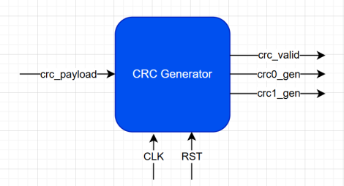
Overview:
The CRC Generator is responsible for protecting transmitted data against corruption.
It receives the partially assembled flit from the Packer and computes two CRC values, CRC0 and CRC1, over fixed portions of the flit.
The CRC calculation includes the flit header, payload data, and any inserted DLLP bytes, while excluding the CRC fields themselves. Once the CRC values are generated, they are returned to the Packer for insertion into the final flit.
This block is critical for enabling error detection at the receiver side and ensuring data integrity across the link.
8 | P a g e
Signal description :-
Port | Direction | Width | Connected | Description
CLK | IN | 1 | ---- | ----------
RST | IN | 1 | ---- | ----------
crc_payload_valid | IN | 1 | packer | Indicates valid data for CRC computation.
crc_payload | IN | 1936 | packer | Flit data excluding CRC fields used for CRC calculation.
crc0_gen | OUT | 16 | packer | CRC value calculated for the first 128 bytes of the flit.
crc1_gen | OUT | 16 | packer | CRC value calculated for the second CRC window.
crc_valid | OUT | 1 | packer | Indicates that CRC calculation is complete and valid.

9 | P a g e
CRC Genrator Operation Description
The CRC generation logic operates in a straightforward manner. Data is received from the Packer, and CRC computation starts immediately.
Two CRC values are generated: CRC0 and CRC1.
CRC0 is responsible for protecting the first 128 bytes of the flit. CRC1 protects the remaining 114 bytes of valid flit data.
In both cases, the CRC window size is fixed, and any unused bytes within the window are treated as zero.
The CRC computation includes both the Flit Header and any DLLP bytes inserted by the Adapter.
After computation is completed, CRC0 and CRC1 are forwarded back to the Packer, and the block asserts crc_valid to indicate that the CRC values are ready for insertion into the flit
10 | P a g e
5)Unpacker
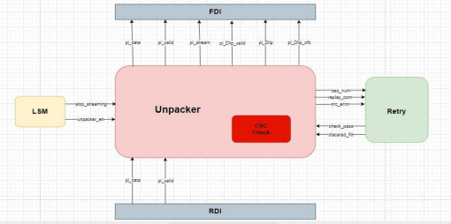
Overview:
The Unpacker operates in the receive path and handles incoming flits from the RDI interface. It buffers the received data and decomposes the flit into its individual components.
The Unpacker extracts the payload data, Protocol ID, Stack ID, DLLP information, sequence number, and replay command from the flit header.
These extracted fields are forwarded to their respective interfaces or internal blocks for further processing. By separating data and control information, the Unpacker enables correct interpretation of received flits and prepares valid payload data for delivery to the protocol layer.
11 | P a g e
Signal description :-
Port | Direction | Width | Connected | Description
Pl_datd_rdi | IN | 2048 | RDI | Full received flit data including header, payload, DLLP, and CRC.
Pl_valid_rdi | IN | 1 | RDI | Indicates that incoming flit data is valid.
Check_pass | IN | 1 | Retry | Asserted by Retry block when sequence and replay checks pass.
Discared_flit | IN | 1 | Retry | Indicates that the current flit must be discarded due to retry failure.
Stop_stream | IN | 1 | LSM | Signal from LSM to stop unpacking and data forwarding.
Unpacker_en | IN | 1 | LSM | Enables the Unpacker to start processing incoming flits.
Pl_data_fdi | OUT | 2048 | FDI | Valid payload data forwarded to the FDI interface.
Pl_valid_fdi | OUT | 1 | FDI | Indicates that the output payload data to FDI is valid.
Pl_stream | OUT | 8 | FDI | Carries Protocol ID and Stack ID information to FDI.
Pl_dllp | OUT | 32 | FDI | Extracted DLLP data forwarded to the FDI interface.
Pl_dllp_valid | OUT | 1 | FDI | Indicates that the DLLP data is valid
Pl_dllp_ofc | OUT | 1 | FDI | Indicates that the DLLP carries optimized flow control  information.
Seq_num | OUT | 8 | Retry | Sequence number extracted from the flit header and sent to Retry block
Replay_com | OUT | 2 | Retry | Replay command extracted from the flit header for Retry handling.
Crc_err | OUT | 1 | Retry | Asserted when a CRC mismatch is detected in the received flit.

12 | P a g e
RX Path Operation Description
When pl_valid is asserted and the Unpacker is enabled, it begins receiving pl_data from the RDI interface.
The received data is first stored in an internal buffer and then decomposed into its constituent fields.
The Stack ID (SID) and Protocol ID (PID) are extracted and driven separately on the pl_stream interface.
Similarly, DLLP information is extracted and forwarded on the pl_dllp interface.
The sequence number and replay command fields are also extracted and sent to the Retry block for validation.
CRC checking is initiated by recomputing the CRC over the received flit data, excluding the CRC fields themselves. The received CRC0 and CRC1 values are forwarded independently to the CRC check logic for comparison.
Once crc_correct is asserted and a check_pass signal is received from the Retry block, the Unpacker asserts pl_valid toward the FDI interface. After that, the payload data, pl_stream, and pl_dllp signals are transmitted to the FDI.
13 | P a g e
6)CRC Check
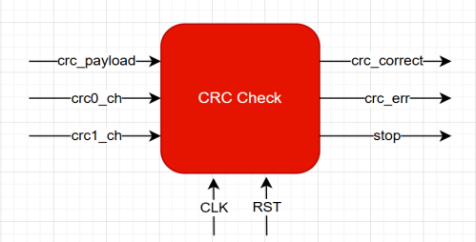
Overview:
The CRC Check block verifies the integrity of received flits.
It recomputes CRC0 and CRC1 using the same fixed windows applied during transmission and compares them with the received CRC values.
If the computed and received CRC values match, the flit is considered valid. In case of a mismatch, the block reports a CRC error and prevents corrupted data from being forwarded.
This block is essential for detecting transmission errors and supporting reliable retry and recovery mechanisms.
14 | P a g e
Signal description :-
Port | Direction | Width | Connected | Description
CLK | IN | 1 | ---- | -------
RST | IN | 1 | ---- | -------
crc_payload | IN | 1936 | unpacker | Flit data excluding CRC fields, used as input to CRC calculation.
crc_payload_valid | IN | 1 | unpacker | Indicates that the received flit data is valid for CRC checking.
crc0_ch | IN | 16 | unpacker | CRC0 value received within the flit.
crc1_ch | IN | 16 | unpacker | CRC1 value received within the flit.
crc_correct | OUT | 1 | unpacker | Asserted when calculated CRC matches received CRC values.
crc_err | OUT | 1 | unpacker | Asserted when a CRC mismatch is detected.
stop | OUT | 1 | unpacker | Requests the unpacker to stop processing the current flit.

15 | P a g e
CRC Check Operation Description
The CRC check block follows a similar operation to the CRC generation logic, with additional control handling.
Incoming data is processed to recompute CRC0 and CRC1 over the same fixed windows used in the transmit path. Along with the data, the received CRC0 and CRC1 values are provided by the Unpacker.
The newly computed CRC values are then compared against the received ones.
If both CRC values match, the block asserts crc_correct, indicating that the flit was received without data corruption.
If a mismatch is detected, a crc_error signal is sent to the Retry block, and a stop signal is asserted to the Unpacker to halt further data forwarding.
16 | P a g e

